OVEA 2007 Twentieth Annual Forum Results
The 2007 Annual Forum was held on November 16, 2007 at The Ohio State University, Museum of Biological Diversity in Columbus Ohio. A record breaking thirty-seven students from seven different universities and colleges took part in the competition.
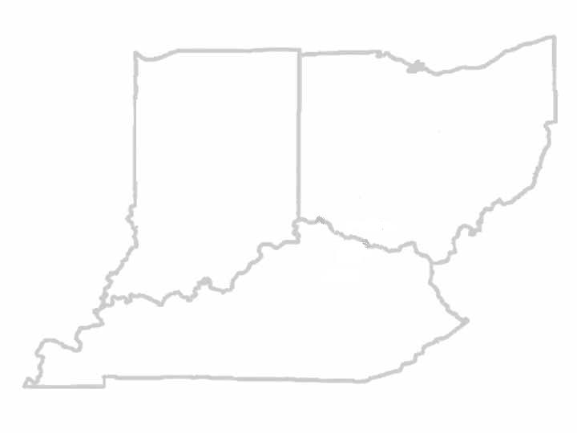
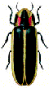
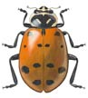

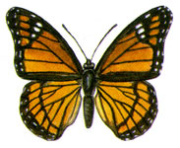

The Ohio State University
University of Kentucky
Purdue University
The College of Mount Saint Joseph
The College of Wooster
Shawnee State University
Wittenberg University

We would like to thank all our judges and moderators for their generous time commitment and important contribution to our association. We would like to acknowledge the following members of OVEA who served as judges and/or moderators at our meeting:
Mr. Josh Benoit, B.S. from The Ohio State University
Dr. Susan Jones from The Ohio State University
Ms. Mijung Kim, M.S. from The Ohio State University
Dr. Hans Klompen from The Ohio State University
Dr. Gene Kritsky from the College of Mount St. Joseph
Dr. Mariam Lekveishvili from The Ohio State University
Mr. Giancarlo Lopez-Martinez, M.S. from The Ohio State University
Dr. Linda Mason from Purdue University
Dr. Daniel Potter from the University of Kentucky
Dr. John Sedlacek from Kentucky State University
Dr. Dave Shetlar from The Ohio State University
Dr. Michelle Solensky from the College of Wooster
Mr. Elijah Talamas, M.S. from The Ohio State University
Dr. Jay Yoder from Wittenberg University

The high light of the meeting was the student presentations. Papers were presented on diverse entomological topics and awards for first, second, and third place were presented in the Bachelor of Science, Master of Science and Doctor of Philosophy, categories as follows:

2007 Student paper Competition Winners:
Bachelor of Science Category
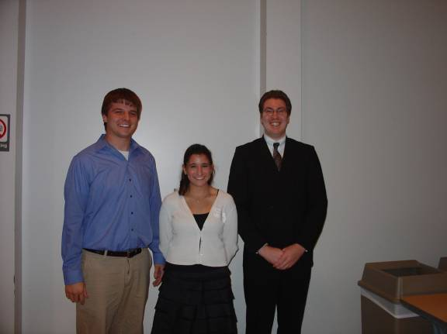
Left to right: Justin Tank, Megan Meuti and Chad Andrews.
First Place: Justin Tank from Wittenberg University presented a paper entitled, “Pathogenic consequences of Metarhizium anisopliae fungal infection averted in ticks by the presence of an internal mycosymbiont”.

Second Place: Megan Meuti from The Ohio State University presented a paper entitled, " The effects of dietary nitrogen on symbiotic nitrogen fixation in the eastern subterranean termite, Reticulitermes flavipes (Isoptera: Rhinotermidae)".

Third Place: Chad Andrews from the College of Mount Saint Joseph presented a paper entitled, “Effects of Dietary Variation on the Early Ontogeny of Haplopelma lividum”.

Master of Science Category
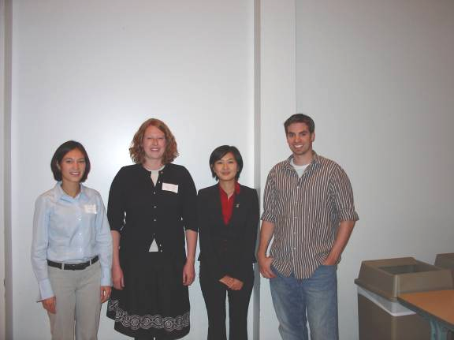
Left to right: Thelma Heidel, Ashley Walter, Ye Ye and J. Ray Fisher
First Place: Thelma Heidel from Purdue University presented a paper entitled, “Assessing the Risk of Non-Target Effects in a Soybean Aphid Classical Biological Control Program”.

Second Place: Ashley Walter from Purdue University presented a paper entitled, “Increasing early detection of invasive species through targeted outreach”.

Third Place: Ye Ye from The Ohio State University presented a paper entitled, “Reproductive Changes in Reticulitermes flavipes Alates (Isoptera: Rhinotermitidae)".

Honorable Mention: J. Ray Fisher from the University of Kentucky presented a paper entitled, “Systematics of Sawfly Slaying Wasps (Ichneutinae)”.

Ph.D. Category
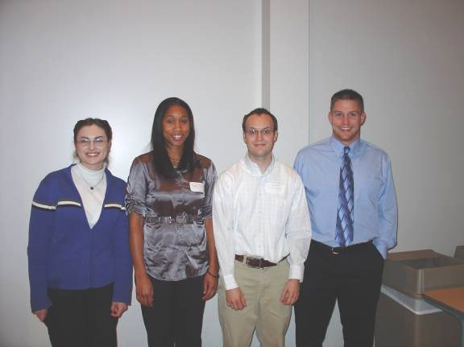
Left to right: Alexzandra McKinnis, Tonya Fisher, Corey L. Brelsfoard and Joshua Benoit
First Place: Joshua Benoit from The Ohio State University presented a paper entitled, “Tolerance of severe dehydration by larvae of the Antarctic midge, Belgica antarctica, is promoted by behavioral and physiological adaptations".

Second Place: Corey L. Brelsfoard from the University of Kentucky presented a paper entitled, “Interspecific Hybridization Yields Strategy for South Pacific Filariasis Vector Elimination”.

Third Place: Tonya Fisher from the University of Kentucky presented a paper entitled, “Investigation of Uncharacterized Open Reading Frames in Campoletis sonorensis Ichnovirus Genome”.
Honorable Mention: Alexzandra McKinnis from Purdue University presented a paper entitled, “The effects of refuge structure on western corn rootworm (Diabrotica virgifera virgifera LeConte) population dynamics and resistance management”.

The OVEA would like to acknowledge the generous support of the following organizations which made the 2007 OVEA Annual Forum possible:
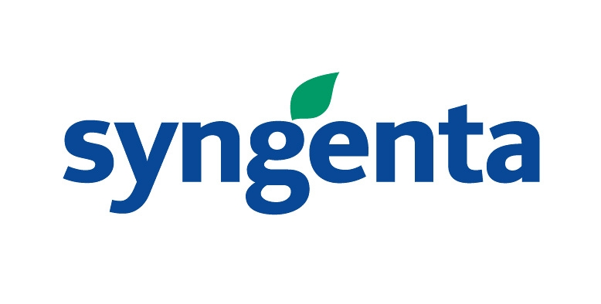
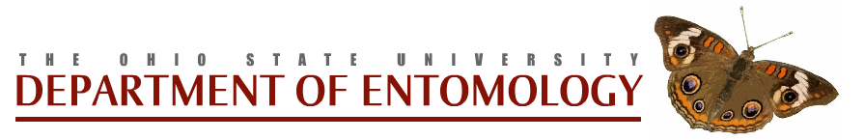







ENSYSTEX
ENSYSTEX

